URBINTEL: Automated Biking Network Planning

by Sebastian S. Szyszkowicz, Ph.D.
Copyright, 2025.

Motivation
Improving safe cycling in a city has great benefits in many areas:
- motor traffic congestion and emissions, amount of parking needed;
  - Our plan to reduce carbon emissions in Canada by at least 0.1%; [see Appendix]
  - "The world’s 280 million electric bikes and mopeds are cutting demand for oil far more than electric cars." [theconversation.com]
- access to workplaces (and commerce, community, entertainment, etc.);
- health benefits (cardiovascular, metabolic, mental, etc.);
- economic impact on commerce;
- cycling gender parity and access for more vulnerable individuals (children, elderly, ...);
- leisure cycling, city beautification, tourism;
- cargo bike access for package delivery;
- "Could Building Bike Lanes Become America’s Next Big Infrastructure Project?" [usa.streetblog.org]
  - "Bike lanes and trails aren't just small, local projects; they're key components of a national effort to end climate change."

Bicycle Tracks
Our technology plans the locations of new bicycle tracks on the existing road and path network:
- Bicycle tracks have a physical barrier (concrete blocks, bollards/pylons, etc.) protecting cyclists from motor traffic.
- On the other hand, bicycle lanes are paint-only designated cycling paths.
- Our algorithm places new bicycle tracks onto streets, either upgrading a bike lane, or as new infrastructure. It may also propose to remove the dismount constraint on certain walking paths.
- Bicycle tracks found safer than on-street cycling [A Lusk, P Furth, P Morency, L Miranda-Moreno, W Willett, J Dennerlein] [K Teschke, C Reynolds, F Ries, B Gouge, M Winters].

Cyclist Profile
Our analysis and planning of the cycling network require a model for the behaviour of the typical cyclist:
- Bicycle trips are calculated from all residential locations to all non-residential locations, using a routing engine.
- Maximum speed: 18 km/h; maximum trip time: 30 minutes; minimum: 10 minutes.
- Level of Traffic Stress (LTS) applies a speed penalty that increases with danger level.
- Road surface type speed penalty based on [OSRM:bicycle.lua].
- Slope climbing speed penalty based on [J Broach, J Dill, J Gliebe] [M Lowry, P Furth, T Hadden-Loh] [C Cooper].
- Speed penalties are NOT cumulative: rather, the worst penalty applies.
- Routing engine finds fastest route, thus avoiding poor biking conditions if an alternative route is available.
- "Four Types of Cyclists" [R Geller]

Why Use this Tool?
A turn-key solution for biking network analysis and planning for your city.
- A custom-built routing engine that is ultra-fast, (20x faster benchmark than the fastest available: OSRM), allowing for the analysis of many scenarios for your city.
- Currently works for Canada, for cities up to about 1,000,000 population. We hope to extend this to further countries and larger cities in the future.
- Implementing USA should be simple enough – requires finding population density files.
- We use only open data, so there are no data costs or privacy concerns.
- Road conflation technology allows combining city's open data (Shapefiles) with OpenStreetMap data.
- Results presented both as image and as vector data (Shapefile or similar).
- Research expertise in biking GIS. Reports for Transport Canada [Szyszkowicz 2018], Public Health Agency of Canada [Szyszkowicz 2019], Province of British Columbia [Szyszkowicz 2022].
- Previous clients (Canada): Sherbrooke QC, Peel Region ON, Hamilton ON, Nanaimo BC, Kamloops BC, Prince George BC, IKEA Corp. Vancouver BC.

Methodology

Level of Traffic Stress (LTS)
Well-established rating system for biking safety on a road:
- Rating can be derived from road properties found in typical open data.
- A function of road type, posted speed limit, on-street parking, number of lanes, cycling infrastructure.
- Can also include measured traffic intensity (ADT/AADT) if available.
- [Mineta Institute, M Mekuria, P Furth, H Nixon].
- It is rare but possible for the LTS rating to be different in both travel directions (F/B Different)
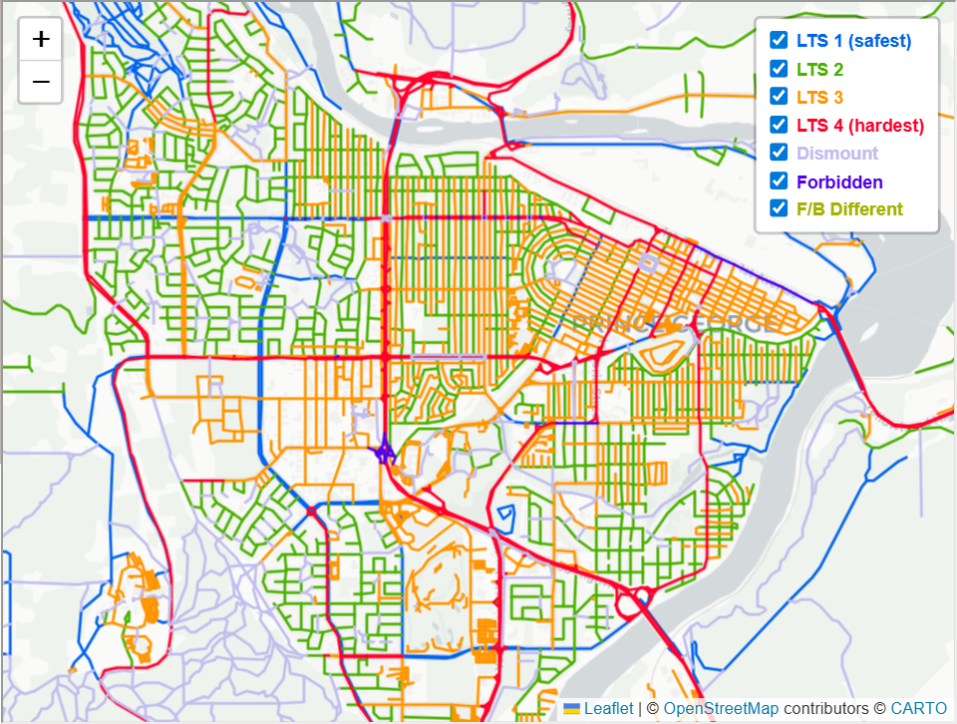
- LTS used in the Bicycle Network Analysis project.

Topography and Slope
- Source: Natural Resources Canada (NRCan)

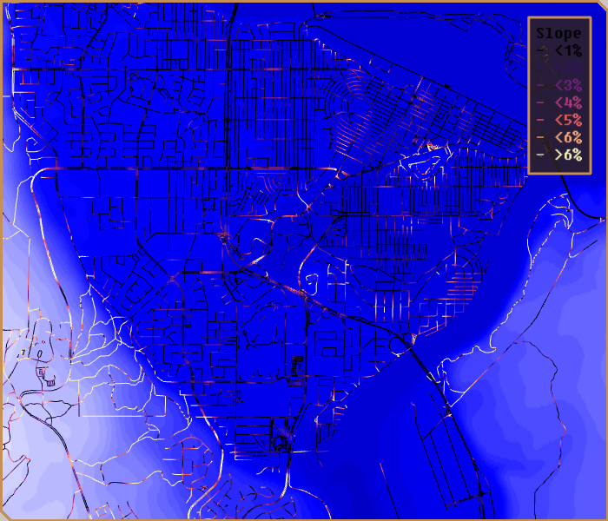

Population Density
- Source: Canadian census [visualization] [US census]
- Within each census parcel ("dissemination area" in Canada), the population is distributed uniformly on the residential streets for simulation purposes.

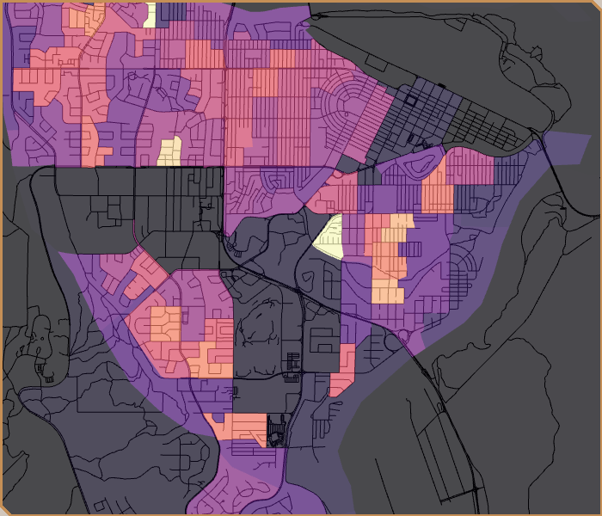

Workplace Density
- Based on building volume and type.
- Buildings taken from OpenStreetMap or city open data.
- Alternatively, can be based on business listing with locations and number of employees, if available.

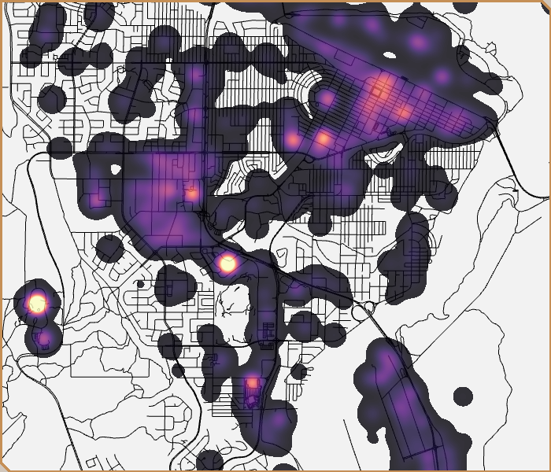

Priority Biking Network Interventions
Output of algorithm: where to place protected bike tracks.
- Based on street segment betweenness centrality (BC) and proprietary optimization algorithm.
- BC in bicycle network planning [M Lowry, P Furth, T Hadden-Loh] [M Lowry: YouTube].
- BC in transportation and urban planning [A Sevtšuk et al.] [B Hillier, T Yang, A Turner] [Y Kaoru, K Yusuke, Y Yuji]
[Y Shen] [M Goremyko, V Makarov, A Hramov, D Kirsanov, V Maksimenko, A Ivanov, A Yashkov, S Boccaletti] [P Crucitti, V Latora, S Porta] [S Lämmer, B Gehlsen, D Helbing] .

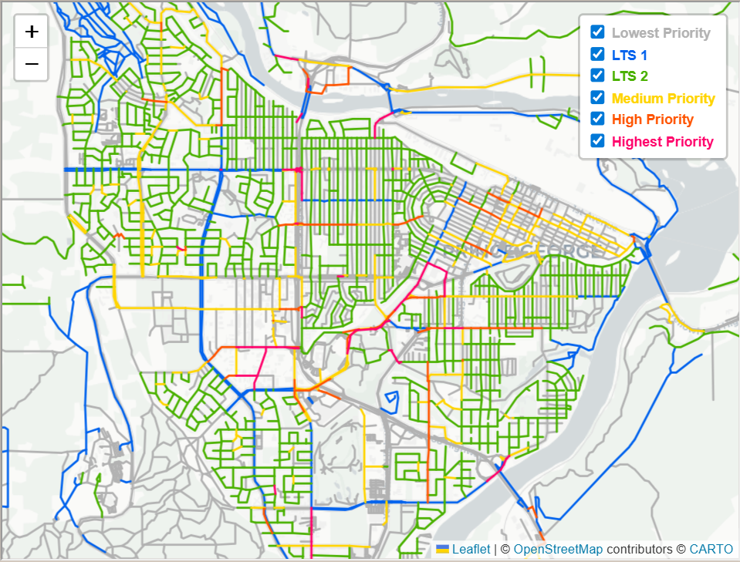

Cycling Potential Curve
Second output of algorithm: tradeoff curve between making the most urgent infrastructure improvements and amount of biking trips improved.
- In this example, building only the most urgent 13% (14 km) of the bike network length results in 50% of the potential gains.

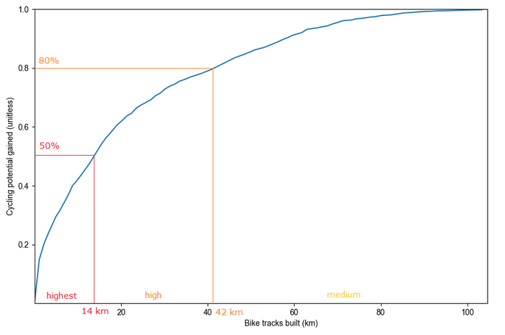

Residential Neighbourhood Accessibility
Third output of algorithm: accessibility of neighbourhoods to workplaces (lighter colours represent better access).
- Metric similar to the one used in the Propensity to Cycle Tool.

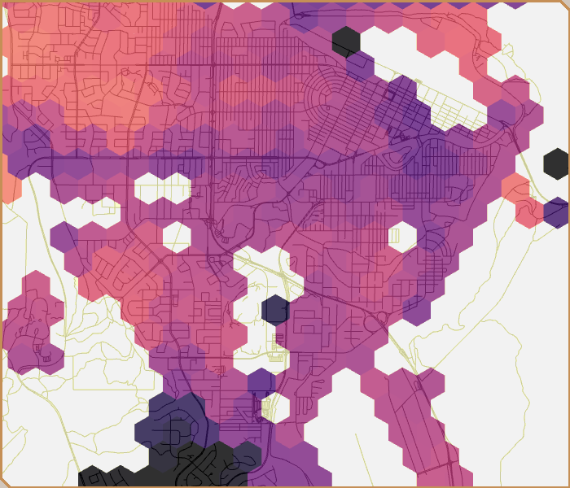

External Resources

Other Significant Projects Related to Biking Networks
- Propensity to Cycle Tool (United Kingdom)
- Bicycle Network Analysis (United States)
- BikeDNA: Bicycle Infrastructure Data & Network Assessment
- BikeScore®
- BikeMaps.org (crowdsourced cycling accident reports)
- BikeOttawa.org (Ottawa, Canada)
- OpenStreetMap; cycling infrastructure can be viewed as OpenCycleMap or CyclOSM.
- [M Winters, M Brauer, E Setton, K Teschke]
- [M Lowry, P Furth, T Hadden-Loh] [M Lowry: YouTube]
- [R Lovelace] paper on open-source GIS tools.

Routing Engines with Biking Profiles
- OpenSourceRoutingMachine (OSRM)
- Mapzen's Valhalla
- GraphHopper
- OpenTripPlanner, OTP Analyst
- Conveyal R5
- CycleStreets
- Cyclopath
- Openroute Service
- Comparisons of some routing engines [F Ramm: YouTube, in German] [Y Akhadi: YouTube].

Some Cycling Plans
- New Zealand cycling plan
- Cycling and walking plan for England
- Vancouver cycling plan
- Vélo Canada Bikes cycling strategy
- New York City bike sharing live map

Appendix
Our low-ball estimate of total yearly CO2 emissions reduction for Canada is 274,000 tonnes. Our optimistic estimate is twice that: 547,000 tonnes. Canada emits about 550M tonnes of CO2 per year. Thus, we are aiming to save 0.1% in carbon emissions. Below is a detailed calculation:

We are looking to replace 3-to-9km-long commutes with bicycle trips. This is an average distance of 6.5 km per trip, or 65 km weekly. Assuming 3 weeks vacation, that's 49x65 = 3185 km yearly per commuter.
Most Canadian cities have about a 2% bike commute participation rate, except Vancouver, which has 6%. A conservative goal would be to bring the participation rate of all other major cities up to 6% - in the summer months. In the winter months, we assume half the participation (based on bike commute rates from Finland: 20%/10%). So we wish to increase increase average participation by 4%*(7/12)+2%*(5/12) given 5 winter months, that is 3.17%.
We are targeting all 62 Canadian cities above 50,000 population except the Greater Vancouver Area. That is 22,300,000 citizens. [2021 Census]
Out of these, we will take as workers those aged 20 to 64, that is 59% of the population.
Typical Canadian cars emit CO2 at an average rate of 206g/km.

The final yearly CO2 saved is 3185km * 3.17% * 22,300,000 * 59% * 206g/km = 274,000 tonnes. This is a low-ball estimate. A few important factors that could increase this estimate are:
- The benefits of reducing traffic are superlinear because during rush hour cars block and slow down other cars and there is lots of idling. Thus, removing X% of cars from the road during rush hour may reduce emissions by much more than X%, because the other cars have a smoother resulting trip.
- This calculation only included daily commutes, but bike lanes can also be used for shopping, community, social, and entertainment trips, all of which help reduce emissions.
- Vancouver may also benefit from more bike lanes and increase its bike commute participation rate even more, as it already has a strong biking culture.
- The 9km travel range is assumed for average-ability cyclists. However, more performant cyclists may replace much longer trips with cycling. Also, the advent of e-bikes may extend the cycling range for many people.
- A well-connected biking network may bring participation higher than 6% in many cities, up to European levels (at least outside winter) of 7% or more, even into the double-digits.

